**PRACTICAL 8**

**Saving Account**

**Code:**

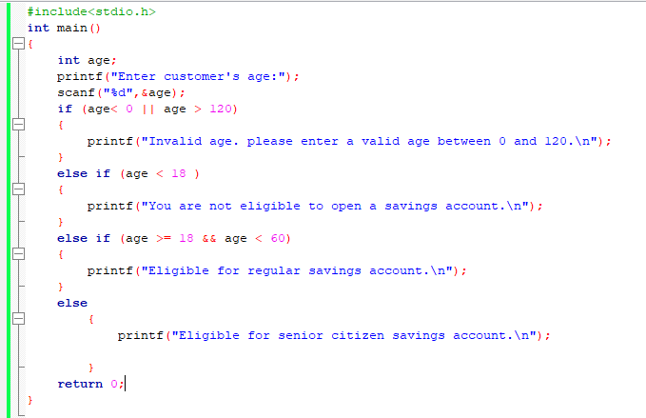

**Output**

**1)for a person with age less than 18**

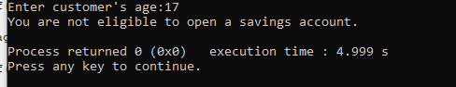

**2) for a normal person**

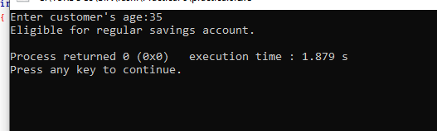

**3)for senior citizen:**

